Customer Retention Case Study

# Executive Summary

This project is based on the case study for customer retention and acquisition and its necessity for developing a proper customer relationship management between firms and their customers. As such, a random forest predictive model is built to predict the customer acquisition for the firm and the accuracy of the model is compared to two other models: decision tree and logistic regression. The random forest model was tuned with calculated optimal hyper-parameters and the variable importance on interaction was also computed. The accuracy rate of the prediction will give a better idea on the better model that could be used for customer retention and acquisition for the firm.

Of the built three models, logistic regression showed the highest accuracy in prediction with 80% accuracy rate and the tuned random forest model came a close second with the accuracy rate of 78.67%. The optimal hyper-parameters as mentioned requires three main parameters: the node size, number of trees and the number of sampled features. And the optimal hyper-parameter values from the results were: mtry = 7 nodesize = 2 and ntree = 6000. To better the model and the case study, better transformations (log, sqrt, var, cubic) could be included and implementation of more modelling techniques could be used such as SVM.

Table of Contents

Executive Summary 1

The Problem 2

Review of Related Literature 3

Methodology 3

Data 6

Findings (Results) 11

Conclusions and Recommendations 16

Partial Dependency Plots (PDP Plots) 17

Appendix 18

References 18

Plots 19

Code 25

# The Problem

The essentials for a good customer relationship management are proper management of customer retention and acquisition. As such, the first step for customer retention and acquisition is prediction on those customers who have a high probability in ending their relationship with the firm as well as the prediction in gaining and acquiring new customers for the firm. The second step is to predict the current customers who are at-risk of leaving or new customers who show high likelihood in joining the firm through various customer incentives such as better communication and pricing offers. In targeting the right customers, the models accurately predicting customer retention and acquisition are crucial as they help in decreasing the cost of the marketing campaign while also making use of the firm’s scares resources competently.

The main task and questions at hand for this case study is to predict those customers who would be acquired and for how long based on the feature set using Random Forest. The case study will also focus on computing the variables importance in detecting the interactions and optimizing the hyperparameters for the acquired customers. As such, a decision tree as well as logistic regression model will also be built to compare the accuracy on the various models for acquiring customers to determine which model would give the best accuracy in prediction for customer acquisition.

# Review of Related Literature

There are many scholarly articles available for customer acquisition and retention. However, a select few are focused on a particular case study and have applied use of various predictive models for achieving their objectives. As such, this paper by S.F. Sabbeh, focuses on the machine-learning techniques for customer retention. As per the paper, various predictive modeling techniques were applied, such as Discriminant Analysis, Decision Tree, SVM, logistic regression, Naïve Bayesian, and multi-layer perceptron. From all the applied modelling techniques, the study perceived ADA and RFC to outperform the other modelling techniques with 96% accuracy and the techniques multi-layer perceptron and SVM a close second with 94% accuracy and the model decision tree came in third with 90% predictive model accuracy (Sabbeh, 2018).

This case study is focused on customer churning, which refers to customer turnover with the use of predictive machine learning techniques. This study by Saran K.A. and Chandrakala D., perceives a good prediction model for customer churn prediction to be a SVM model combines with boosting algorithms that will outperform other models with a higher accuracy. The study focused on various predictive models using machine learning and their effectiveness in customer churn prediction with models such as SVM, logistic regression, boosting algorithms, rotation-based ensemble classifiers, PLS (Partial Least Squares), GAMs and more. Amongst all these models and algorithms, they suggested the use of SVM with boosting algorithms for better accuracy in customer prediction (A., D., 2016).

# Methodology

The dataset for the case study is from the SMCRM package called acquisitionRetention and holds 500 observations for 15 variables. Among the 15, our target variables are two: ***acquisition*** and ***duration***. From these variables, one variable ***customer*** does not contribute to any of the model and is thus removed from the dataset. The models that are being used for this case study is Random Forest, Logistic Regression and Decision Tres.

Random Forest model is an algorithm based on classification that operates by constructing numerous decision trees during training the dataset. The random forest algorithms are based on three main hyperparameters: node size, number of trees and the number of sampled features. The advantages and disadvantages to using random forest algorithms are:

***Advantages:***

* Uses bagging algorithm and ensemble learning technique thereby reducing overfitting and variance while improving the overall accuracy
* Can be used to solve both classification and regression problems

***Disadvantages:***

* Takes longer training time and depends the decision on most of the votes.
* It is a complex method creating a lot of trees thereby requiring more computational resources.

The other two models that are being used in the case study are decision trees and logistic regression. Decision tree model is a non-parametric method with tree-like models of decisions that is generally used for classification and regression, where the internal node represents a test and each branch represents the outcome of the test, while each leaf holds the class label. The advantages and disadvantages to using decision tree models are:

***Advantages (Decision Tree):***

* The model can handle both categorical and continuous variables and does not require feature scaling.
* The model handles missing values and is robust to outliers and requires less training period.

***Disadvantages (Decision Tree):***

* The model has issues with overfitting and high variance.
* The model could be unstable with adding a new data point and is affected by noise.

Logistic Regression is a classification algorithm that is used to find out if the probability of the event is a success or not. This algorithm is mainly in use when the dependent variable is binary. This algorithm learns a linear relationship from the dataset and presents a non-linearity.

***Advantages (Logistic Regression):***

* The model makes no assumptions on the distribution of the classes in the feature space.
* The model can extend to multiple classes of regression and provides a measure of coefficient size and its direction of association.

***Disadvantages (Logistic Regression):***

* The model constructs linear boundaries.
* The model has the limitation of assumption of linearity between the dependent and independent variable.

The provided dataset was checked to have null values or duplicate values and was found to have none of both. Thus, the data was already clean, and the exploration of dataset was done to understand the data. During the process, we found that the variable ***customer*** did not input ay significance for the predictive model, which is why the variable was removed and the dataset was taken as a data frame to work with further in the case study.

The main aim of the case study was to:

* make predictions on which customers will be acquired and for how long(duration) based on the feature set while using a random forest algorithm.
* compute the variable importance to detect interactions and optimize hyper-parameters for acquired customers.
* compare the accuracy of the random forest algorithm with decision tree and logistic regression for acquiring customers.
* create PDP plots for the variable.

All the tasks were accomplished by following the objectives below:

* getting the dataset from the SMCRM package
* adding the dataset to the data frame and exploring the dataset.
* splitting the data set to training and testing data.
* using random forest algorithm for ***duration***.
* made predictions on the test dataset.
* using random forest algorithm for ***acquisition***.
* made predictions on the test dataset.
* tuning the random forest by calculating the optimal set of hyperparameters.
* finding the variable importance to detect interactions
* built decision tree model
* built logistic regression model
* compared the accuracy of the built models
* generated the PDP plots.

In the random forest algorithm, while making the predictive model for ***duration***, we made use of all the variables still present in the dataset. However, when building the predictive model for ***acquisition***, we used only four variables: ***acq_exp, industry, revenue,*** and ***employees***. The reason behind using only the mentioned variables and not all from the dataset is because using all the variables from the dataset resulted in ***a perfect separation*** in the prediction results. Perfect separation can also be referred to as perfect prediction and this occurs when the outcome of the result variable separates the predictor variable completely. In our case, the outcome variable was perfectly predicted to 1 and 0 in reference to the predictor variable.

OOB Error (Out of Bag error) is the average error for each of the prediction from the random forest or any other machine learning model. This method uses subsampling in replacement to create training sample for the model to learn from during training. As such, the next step was to compute the variable importance to detect interactions. The variable importance is computed after building a random forest model to answer the driver variables from the outcome that are of high importance having a significant impact on the predicted outcome. Computing the variable importance on interactions yields the variables that interplays with at least two independent variables on the outcome variable.

After computing the variable importance to detect interactions and optimizing the hyper-parameters for the acquired customers, we moved to build the decision tree model and logistic regression model to compare the accuracy between the built models and determine which model yielded the highest accuracy in prediction with customer.

# Data

The data for this case study is taken from the SMCRM package and can be accessed in R studio through the code:

*Data(acquisitionRetention)*

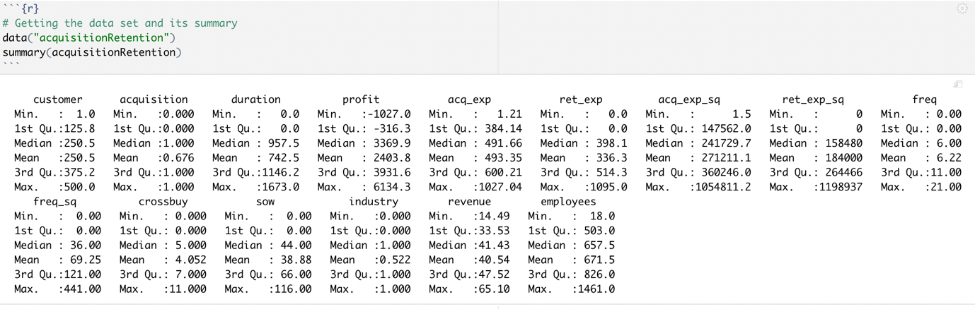

*Fig: Summary of the data set*

The dataset holds 500 observations of data between 15 variables. Of the 15 variables, we have two target variables: ***acquisition*** and ***duration***. ***Acquisition*** variable holds the value on whether the prospective customer was acquired (i.e., 0 for not acquiring the customer and 1 for acquired). Similarly, the ***duration*** variable holds the value for the number of days (duration) of the customer in the firm. Of the 15 variables, we will be working with 14 variables, thereby eliminating the variable ***customers***, which holds the number of customers in the dataset and the variable is not useful for this analysis.

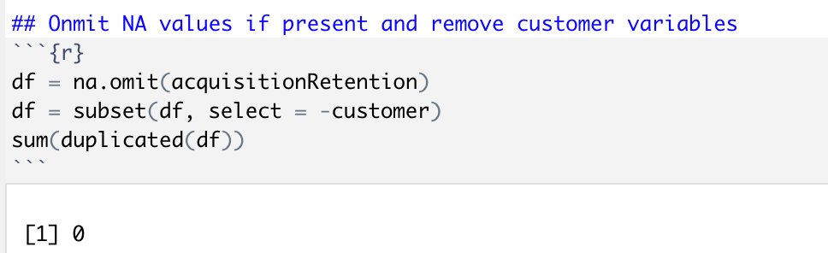

*Fig: Removing customer variable from the data set and checking for duplicates/ NA*

For data cleaning, we checked for null values and duplicates in the data set and found none. Because the dataset was already clean, no data preprocessing was required. The dataset showed no severe limitations to work with. However, the variables in the data set showed perfect separation in one of the predictive models which was overcome by using only some of the variables and not all of it. This has been discussed in the methodology section. As such, the only play with the data set was when the variable ***customer*** was removed because the variable only held the serial number of the customers in the data set and held no significance to the predictive model.

The 15 variables and what they represented in the SMCRM package of acquisition Retention is as shown below:

* ***customer***: customer number from 1 to 500
* ***acquisition***: 1 if the prospect was acquired, 1 otherwise
* ***duration***: number of days the customer was a customer of the firm. 0 is acquisition ==0
* ***profit***: customer lifetime value (CLV) of a given customer, -(acq_exp) if the customer is not acquired
* ***acq_exp***: total dollars spent on trying to acquire this prospect
* ***ret_exp***: total dollars spent on trying to retain this customer
* ***acq_exp_sq*:** square of the total dollars spent on trying to acquire this prospect
* ***ret_exp_sq***: square of the total dollars spent on trying to retain this customer
* ***freq***: number of purchases the customer made during that customer’s lifetime with the firm, 0 if acquisition ==0
* ***freq_sq***: square of the number of purchases the customer made during that customer’s lifetime with the firm
* ***crossbuy***: number of product categories the customer purchased from during that customer’s lifetime with the firm, 0 if acquisition == 0
* ***sow***: Share-of-Wallet; percentage of purchases the customer makes from the given firm given the total amount of purchases across all firms in that category.
* ***industry***: 1 if the customer is in the B2B industry, 0 otherwise
* ***revenue***: annual sales revenue of the prospect’s firm (in millions of dollars)
* ***employees***: number of employees in the prospect’s firm

The visualization of the variables and exploratory analysis of the data can be found in the appendix section under plots and below respectively.

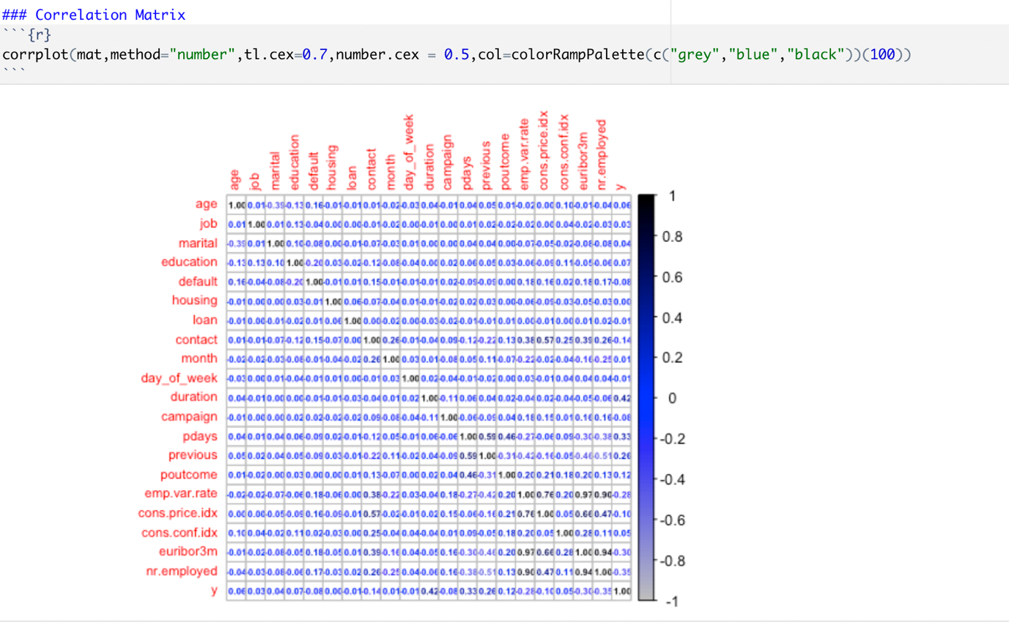

*Fig: Correlation Matrix*

The correlation matrix result above shows that the variables ***duration, Profit, ret_exp, ret_exp_sq, freq, crossbuy*** and ***sow*** variables have high correlation with the variable ***acquisition***.

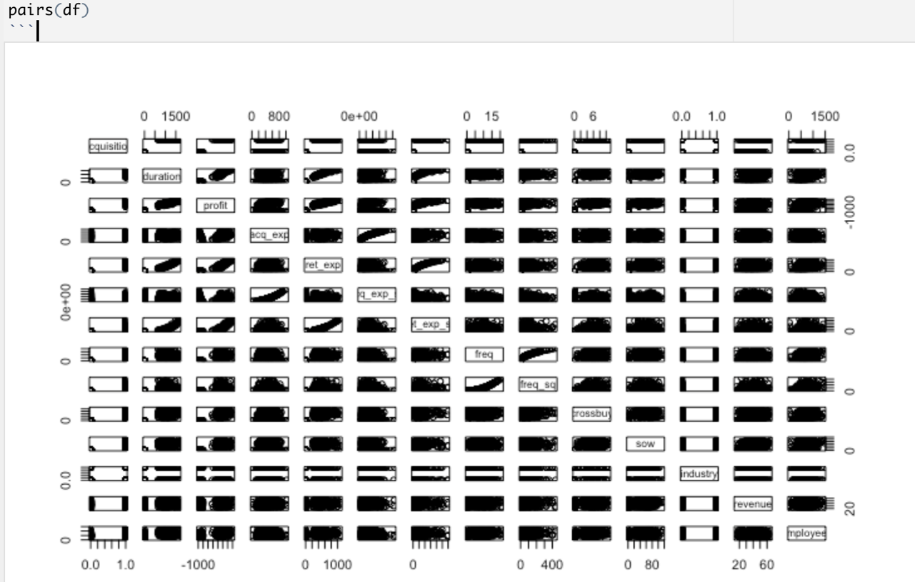

*Fig: Pairwise plot for all variables*

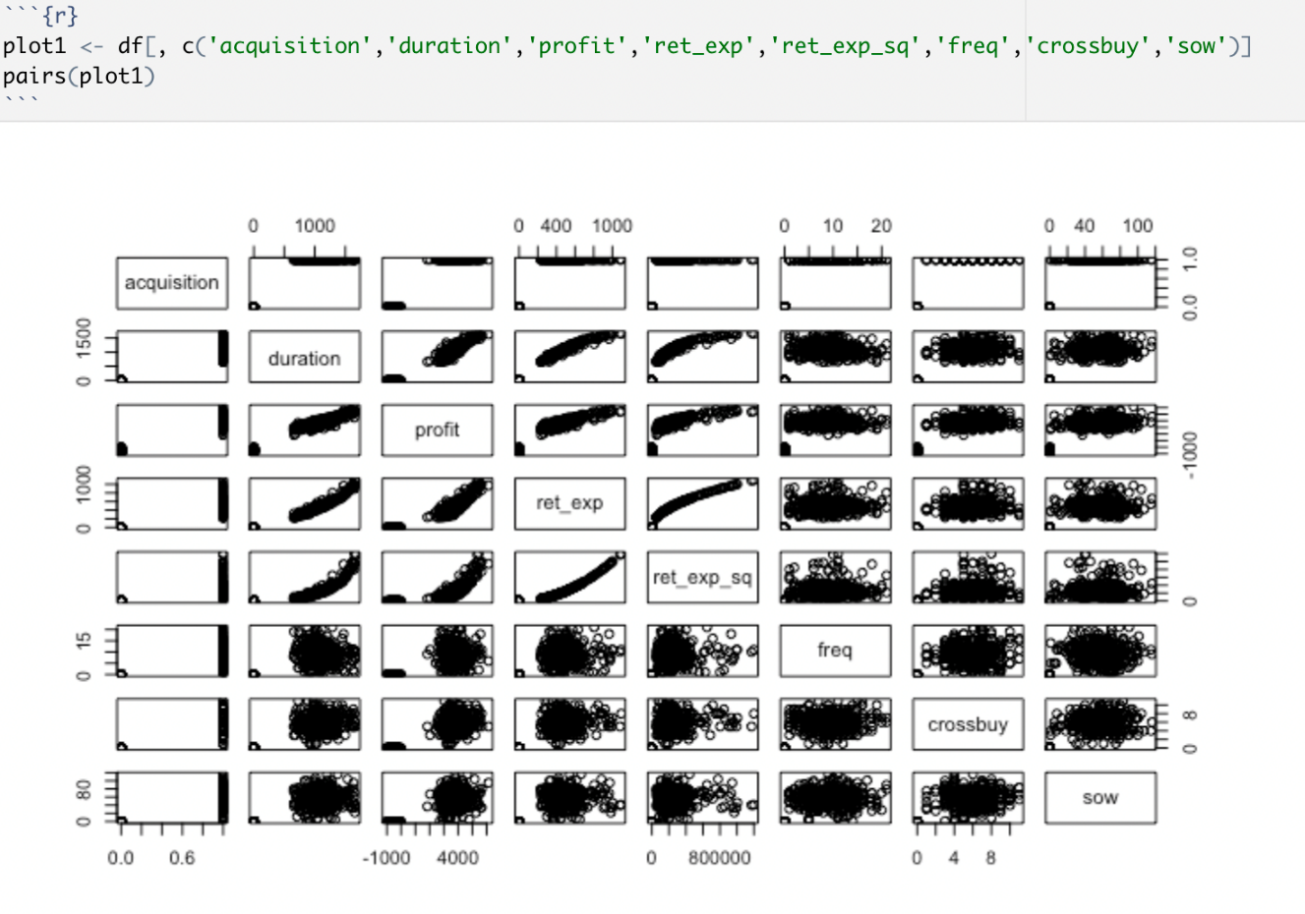

*Fig: Pairwise plot between the variables showing high correlation*

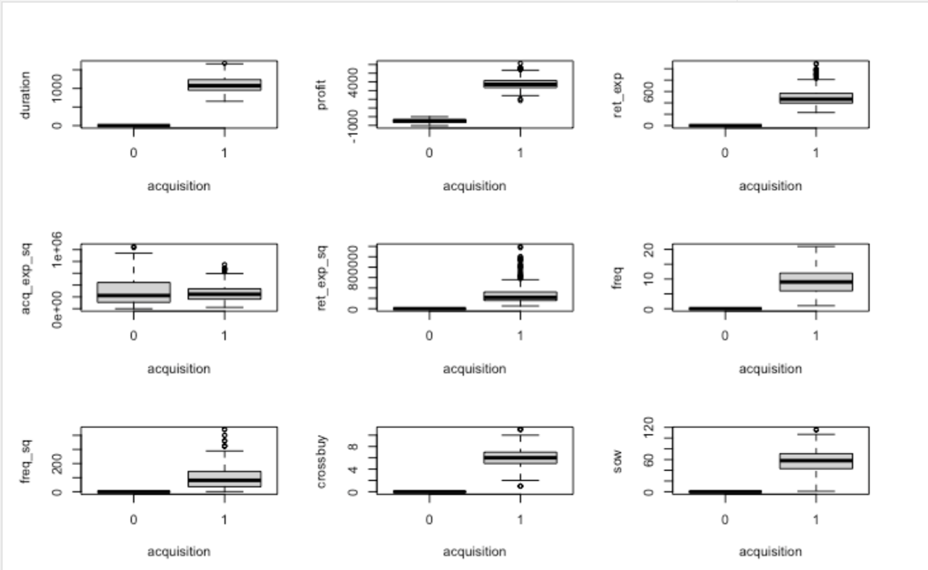

*Fig: Box plot between the variables showing high correlation*

# Findings (Results)

The screenshots showing the confusion matrix for the built models along with the results of the optimal hyper-parameters, variable importance on interactions is shown below. The model that yielded the highest rate of accuracy was logistic regression with 80% and the tuned random forest a close second with 78.67% accuracy rate.

Sensitivity is the ability to correctly identify customers being acquired (acquisition = 1 class).

Specificity is the ability to correctly identify customers not being acquired (acquisition = 0 class). Sensitivity is important for acquisitions as true positives are critical and false negatives are red flags. Sensitivity is important for this data as we don’t want to miss out the customers that can be acquired.

The model with best sensitivity is good here and the model with the best sensitivity is the tuned random forest model. The table showing the comparison of the accuracy, sensitivity and specificity between the predictive models built are included below:

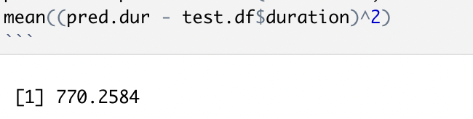

*Fig: test mean error from random forest for duration prediction*

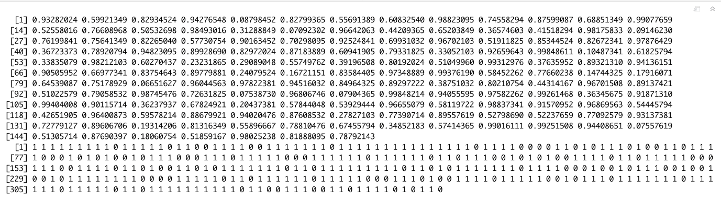

*Fig: prediction result for acquisition from untuned random forest*

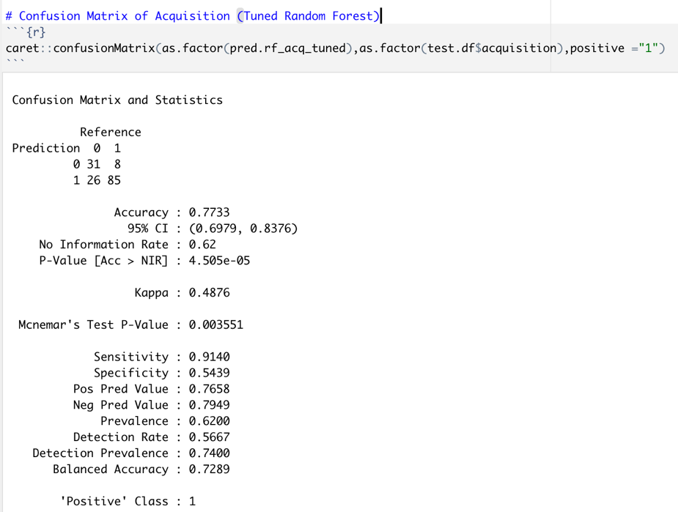

*Fig: confusion matrix for acquisition from untuned random forest*

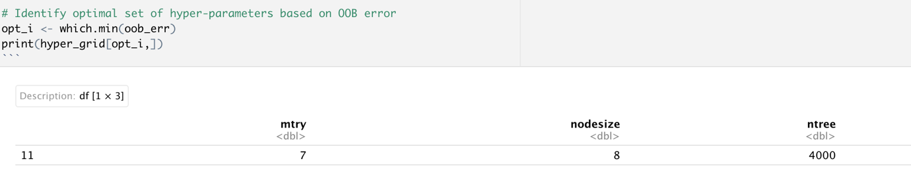

*Fig: Optimal set of hyper parameters based on OOB Error*

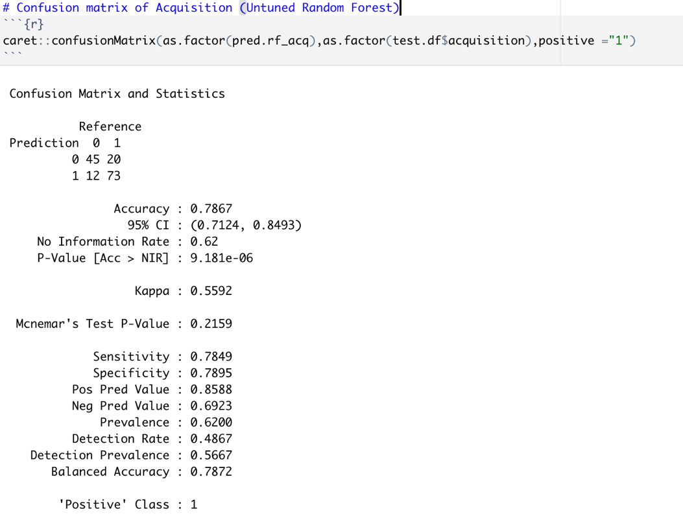

*Fig: confusion matrix for acquisition from tuned random forest*

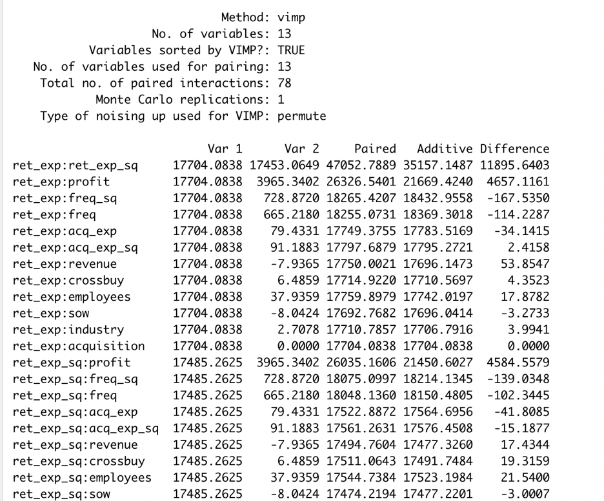

*Fig: vimp method for checking the interaction variable*

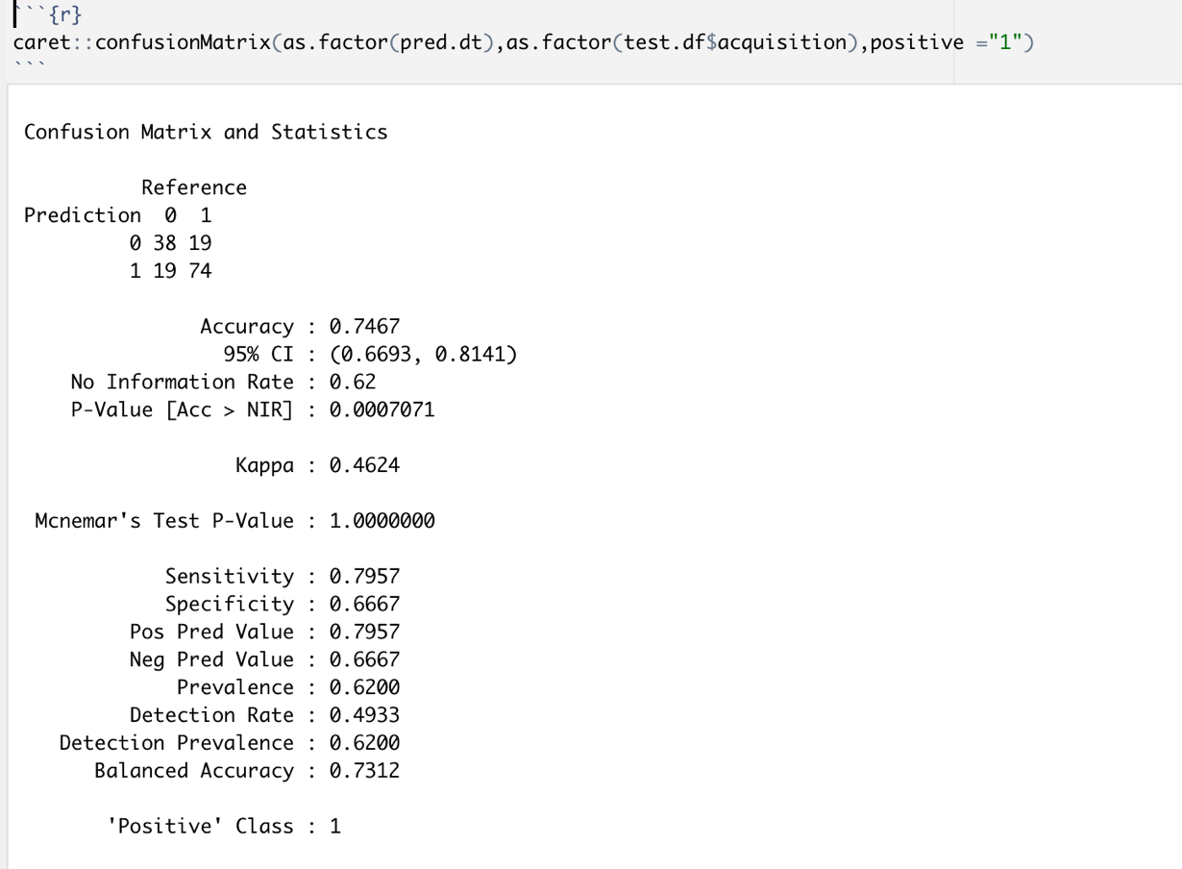

*Fig: confusion matrix for decision tree model*

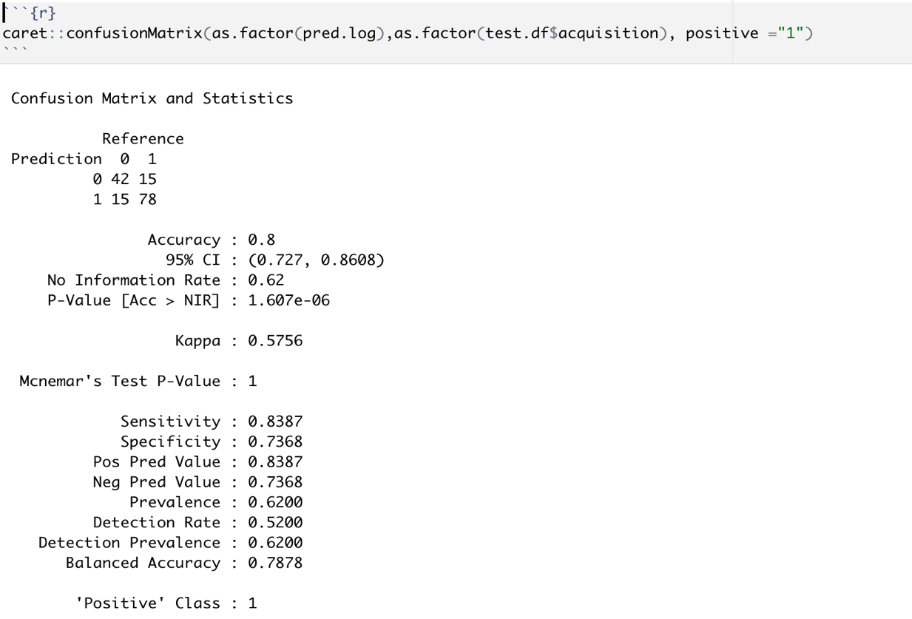

*Fig: confusion matrix for logistic regression model*

|  |  |  |  |
| --- | --- | --- | --- |
| Predictive Models | Accuracy | Sensitivity | Specificity |
| Random Forest (Untuned) | 77.33% | 0.7849 | 0.5439 |
| Random Forest (Tuned) | 78.67% | 0.9140 | 0.7895 |
| Decision Trees | 74.67% | 0.7957 | 0.6667 |
| Logistic Regression | 80.00% | 0.8387 | 0.7368 |

*Table showing the comparison of each of the models.*

From the results shown, we can conclude that our tuned random forest model yielded better results than the untuned random forest as well as the decision tree model. The most important variables for predicting ***duration*** are ***ret_exp_sq, ret_exp, interaction_ret_exp_profit*** and ***profit.*** The optimal hyper-parameters as mentioned requires three main parameters: the node size, number of trees and the number of sampled features. As such, from the results, we can see that the optimal model held the value for the hyper-parameters as:

* mtry = 7
* nodesize = 2
* ntree = 6000

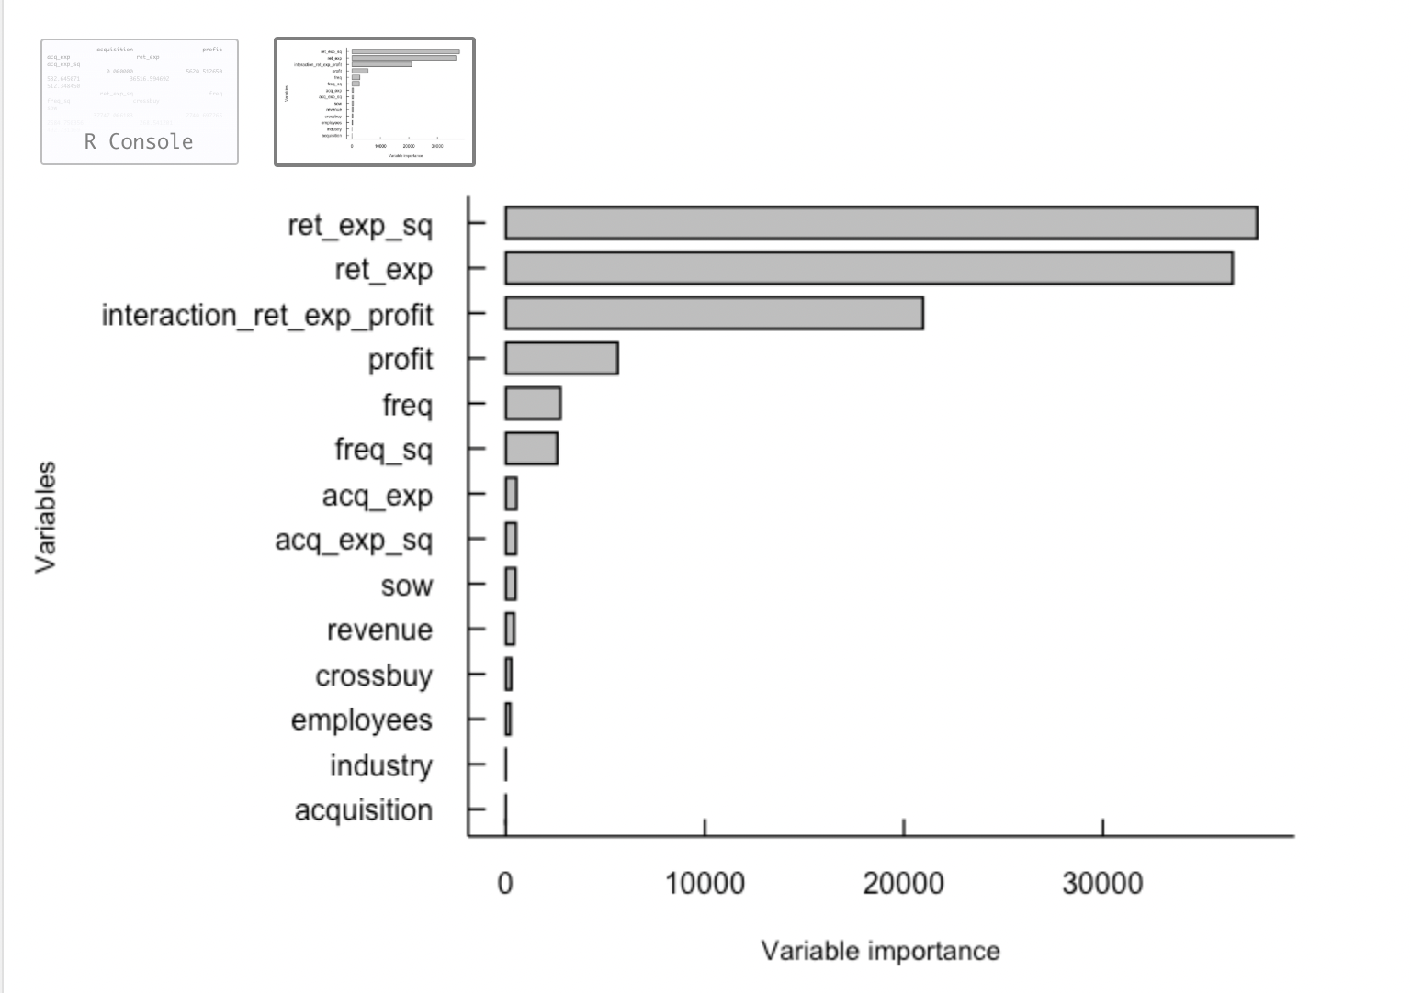

*Fig: variable importance*

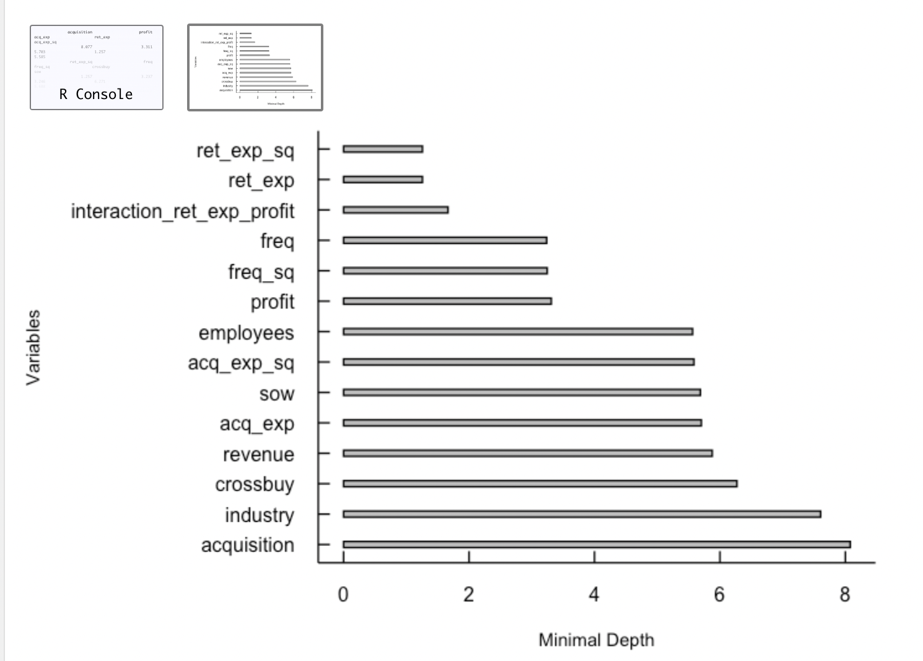

*Fig: variable importance*

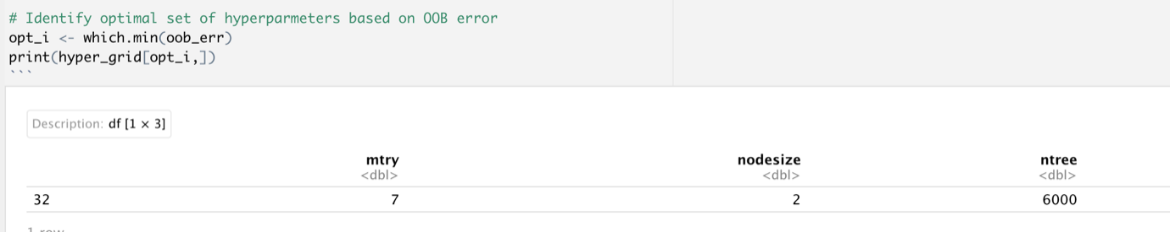

*Fig: Yielded results for optimal hyper-parameters*

# Conclusions and Recommendations

From the findings above, we can conclude that the higher accuracy from all the models was given by the logistic regression model with the accuracy rate of 80%, which is the highest among all the other models that were built. As such, the tuned random forest model came to the close second with 78.67%. This shows that the use of calculation of the optimal hyper-parameters can help in tuning a random forest model to provide better rate of accuracy.

For better results and accuracy for the model, implementation of transformations (log, cubic, var, sqrt) would better the predictive models. Pruning of the decision tree could have yielded better results with the decision tree model. In addition, the use of SVM model in combination with boosting algorithms would yield better and higher accuracy outperforming other models and yielding better predictions.

# Partial Dependency Plots (PDP Plots)

***Duration:***

* Duration shows strong positive partial dependence on retention expenditure, square of retention expenditure and interaction of retention expenditure and profit.
* Negative partial dependence is observed for frequency and square of frequency.

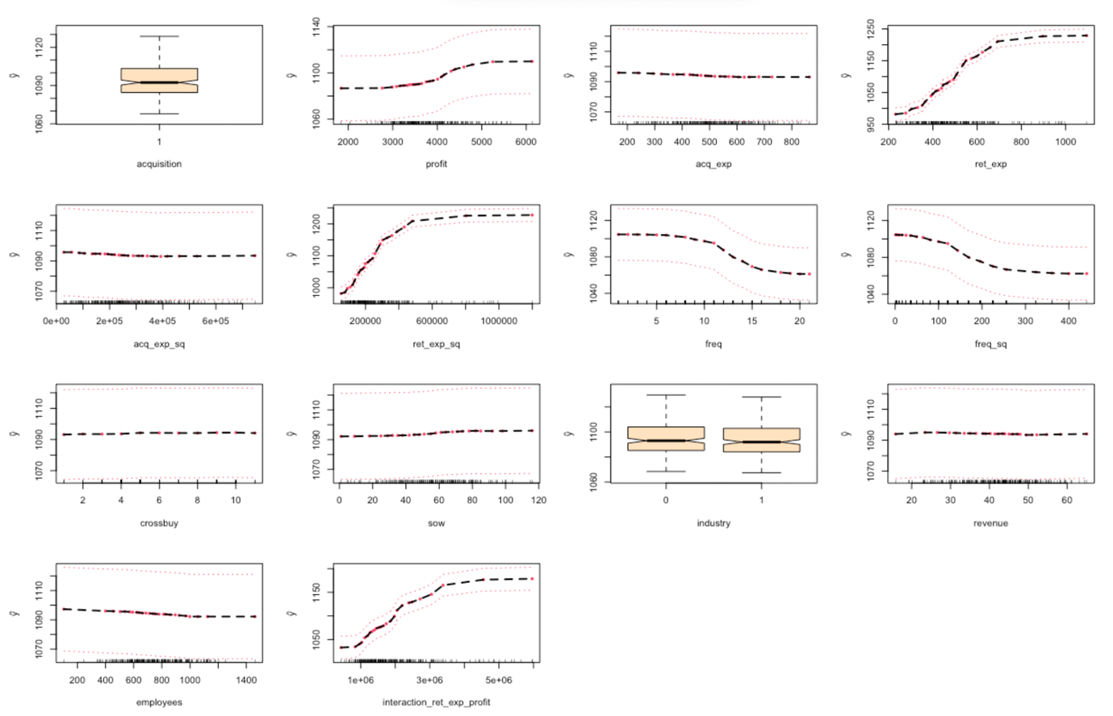

*Fig: PDP plot for duration*

***Acquisition***

* Probability of acquisition is high for employees greater than 700 and low for employees less than 500.
* The probability of acquisition increases with increase in revenue. Probability of acquisition is high if customer is in B2B industry (industry = 1).
* For acquisition expenditure between 400 and 700, probability of acquisition is high.

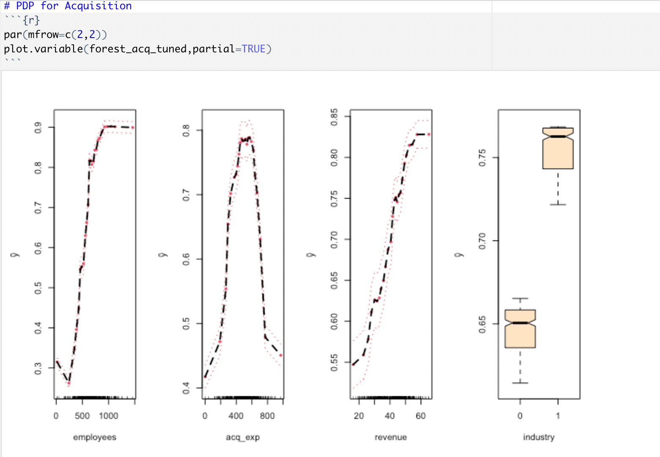

*Fig: PDP plot for acquisitioin*

# Appendix

## References

* F., S., 2018. Machine-Learning Techniques for Customer Retention: A Comparative Study. *International Journal of Advanced Computer Science and Applications*, [online] 9(2). Available at:

<https://thesai.org/Downloads/Volume9No2/Paper_38-Machine_Learning_Techniques_for_Customer_Retention.pdf>

[Accessed 6 April 2022].

* A., D., S., 2016. Literature survey. *International Journal of Computer Applications (0975 – 8887)*, [online] 154(10). Available at: <https://www.ijcaonline.org/archives/volume154/number10/kumar-2016-ijca-912237.pdf>

[Accessed 8 April 2022].

## Plots

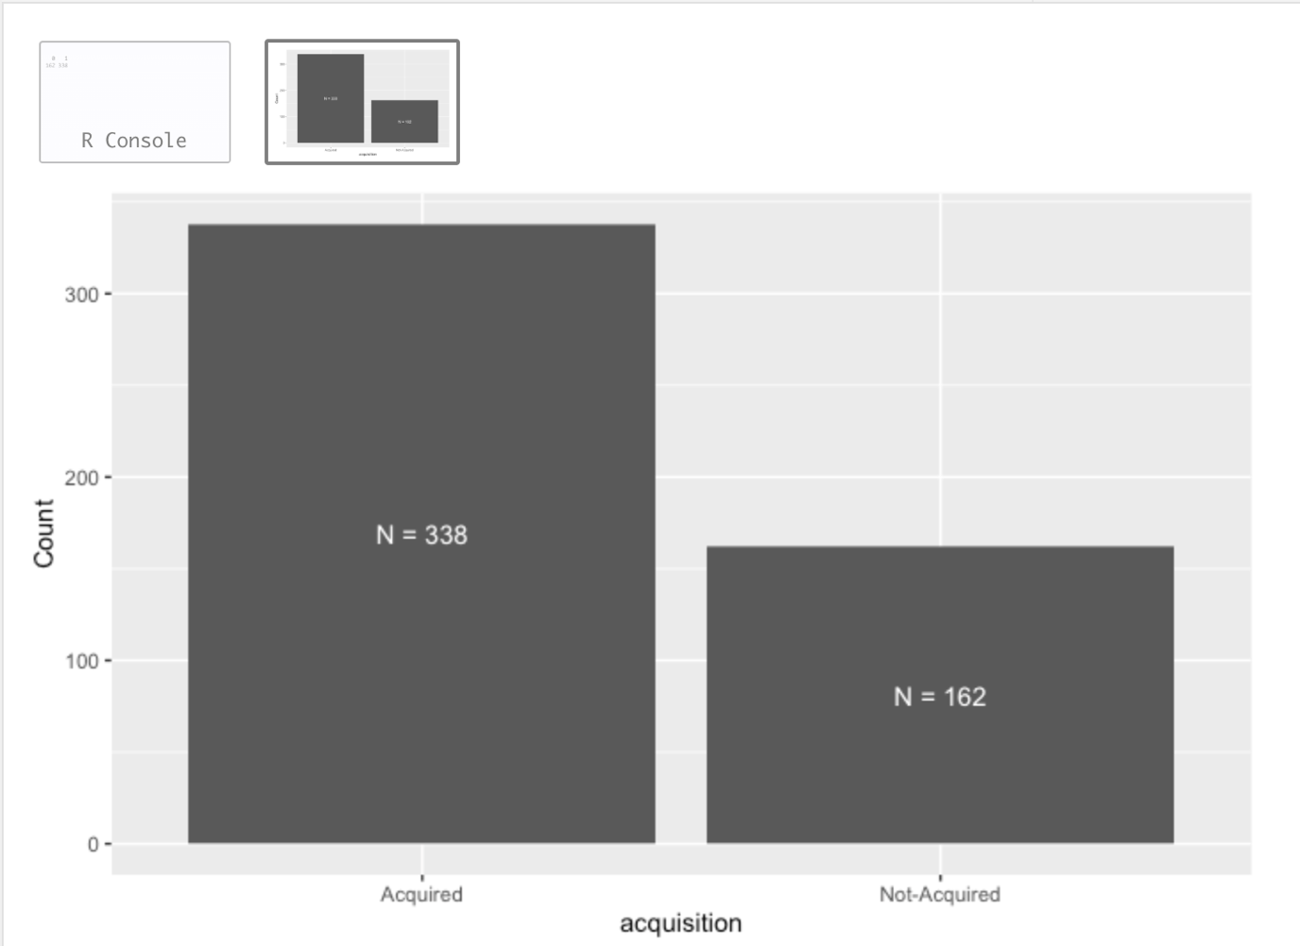

*Fig: visualization of variable acquisition*

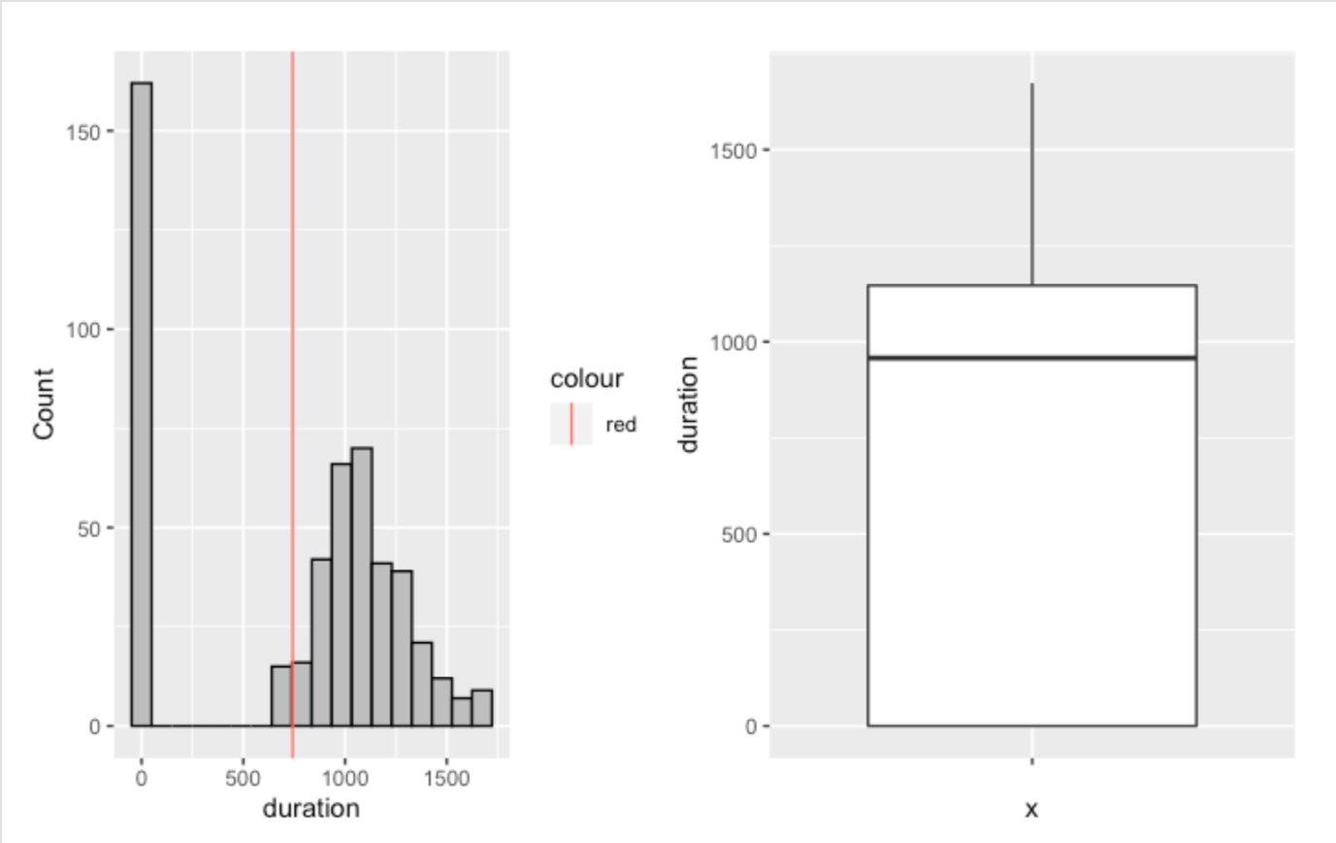

*Fig: visualization of variable duration*

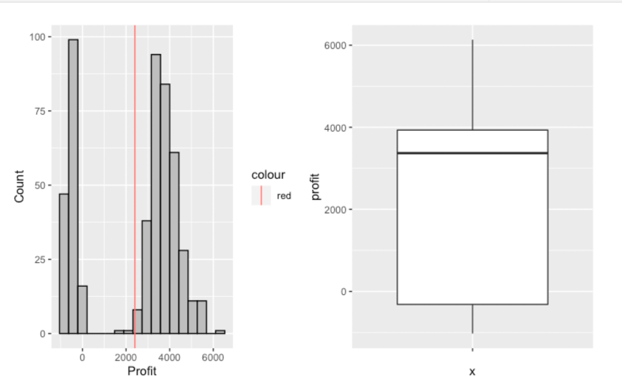

*Fig: visualization of variable profit*

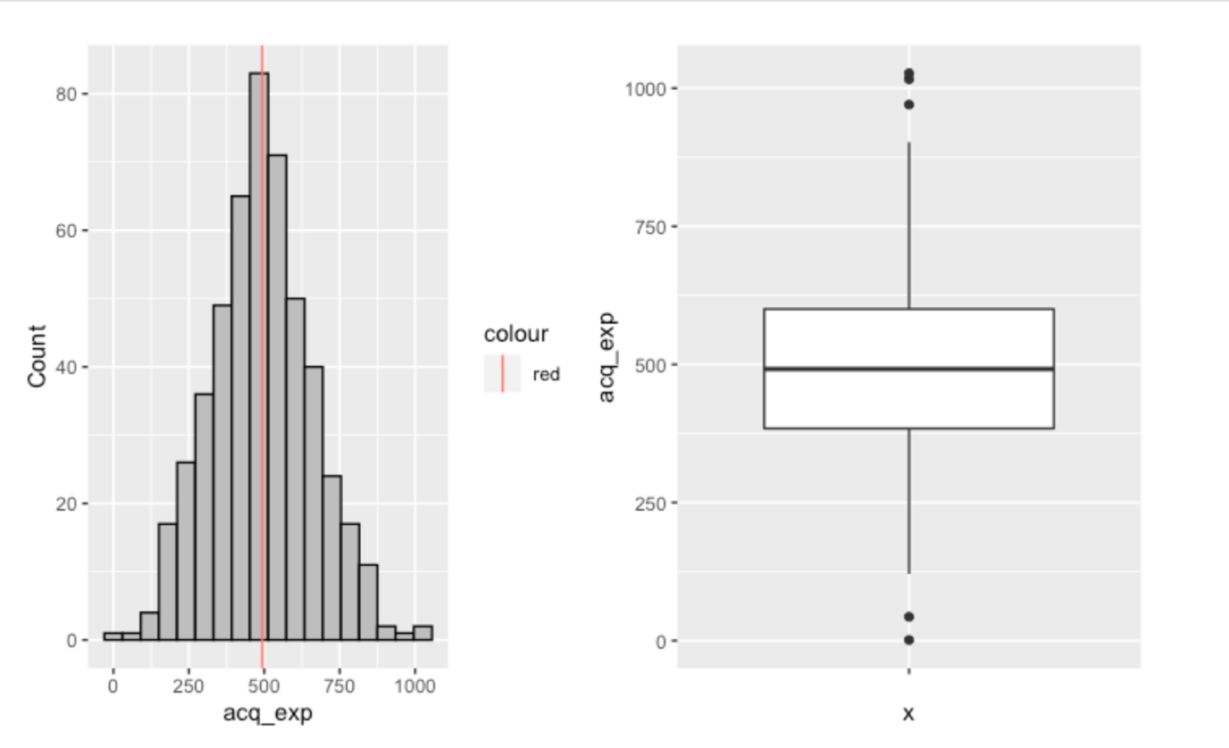

*Fig: visualization of variable acq_exp*

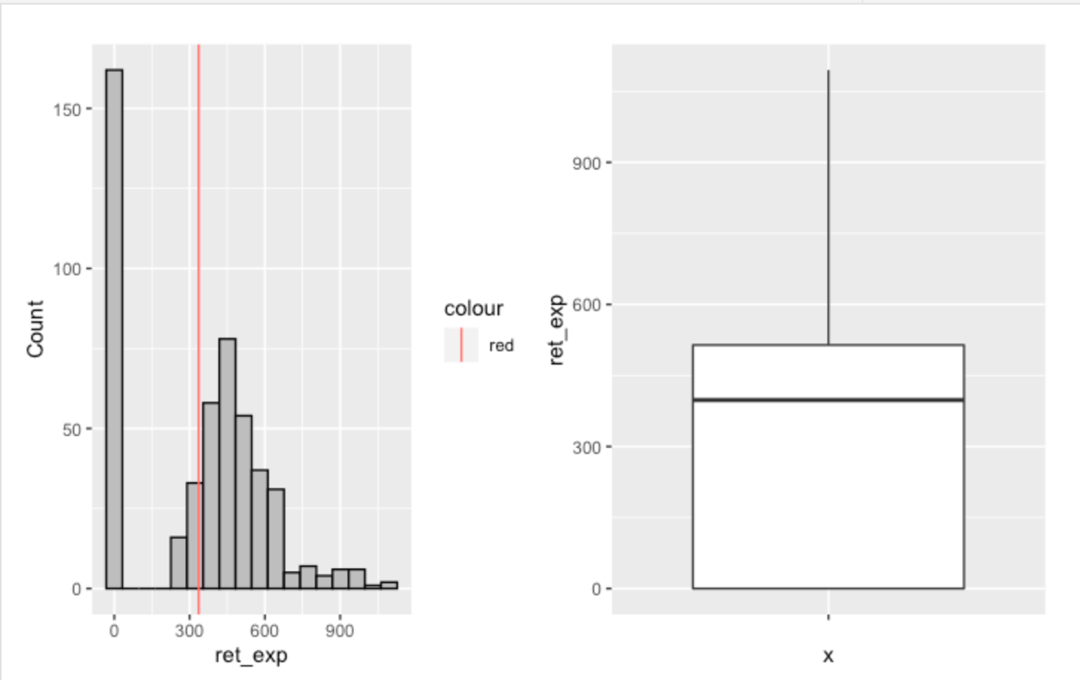

*Fig: visualization of variable ret_exp*

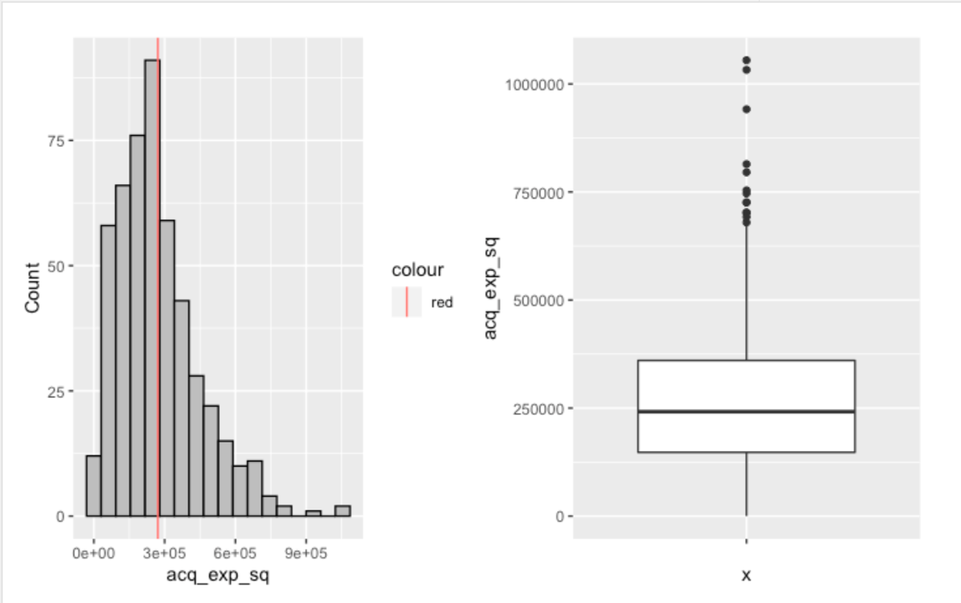

*Fig: visualization of variable acq_exp_sq*

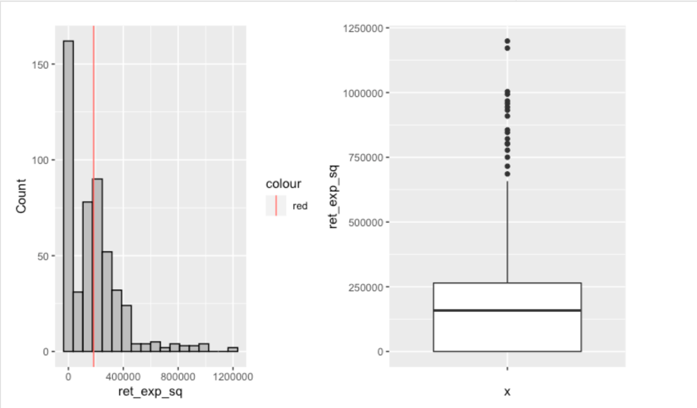

*Fig: visualization of variable ret_exp_sq*

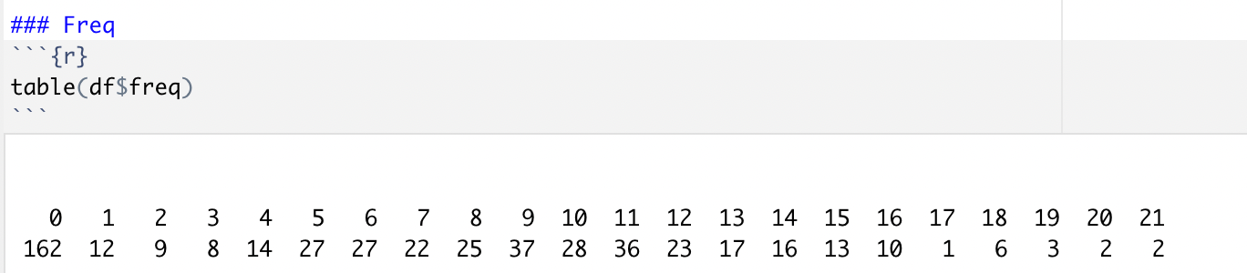

*Fig: table showing frequency for variable freq*

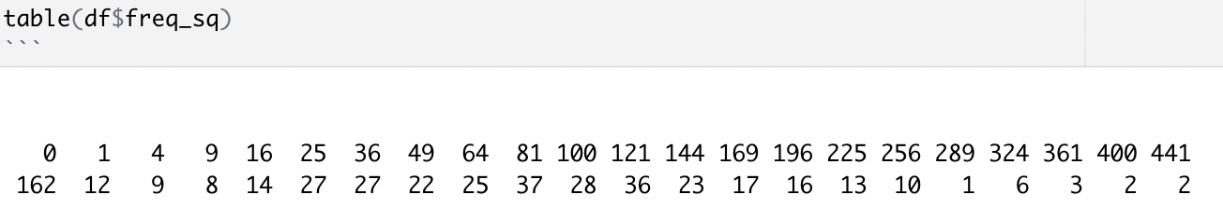

*Fig: table showing frequency for variable freq_sq*

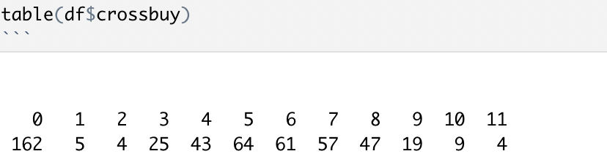

*Fig: table showing frequency for variable crossbuy*

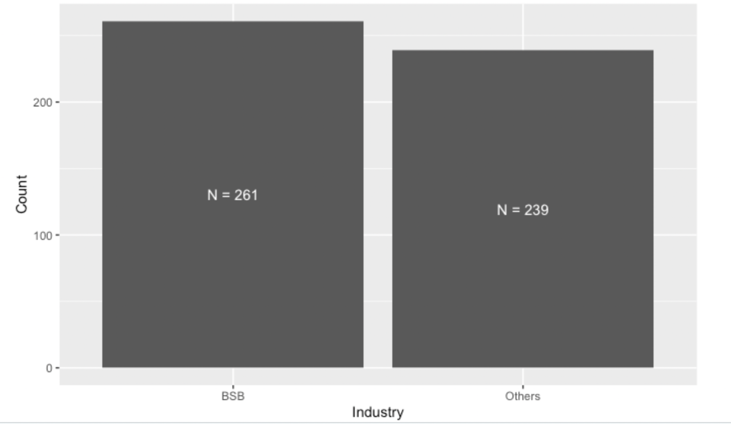

*Fig: visualization of variable industry*

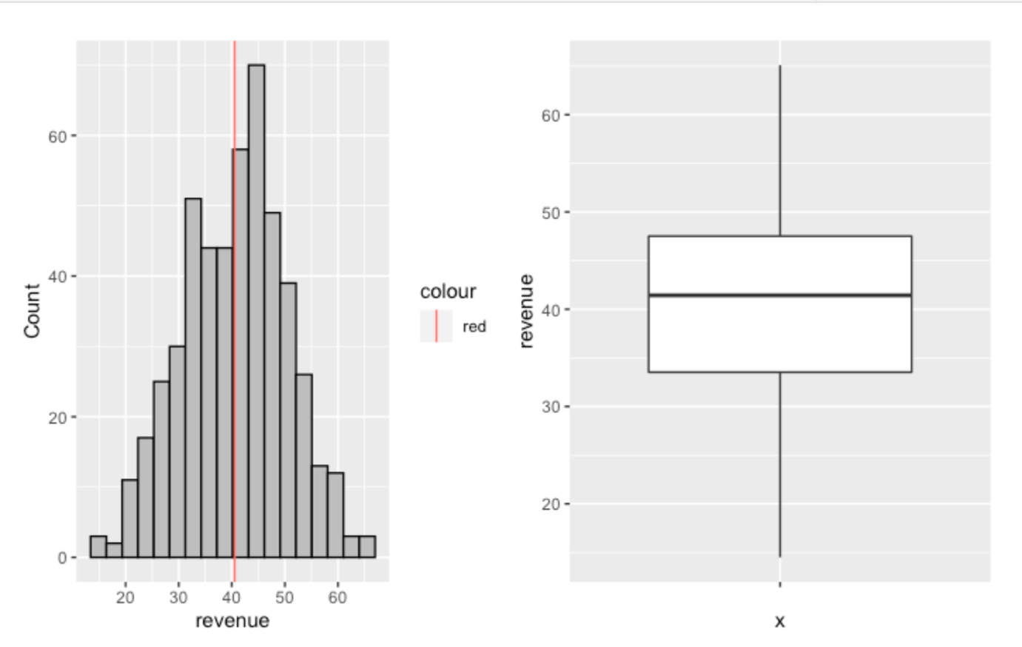

*Fig: visualization of variable revenue*

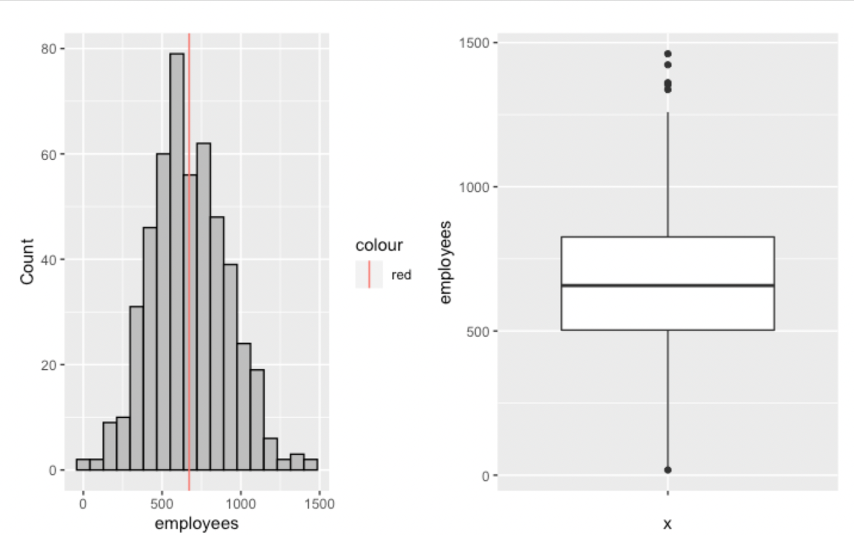

*Fig: visualization of variable employees*

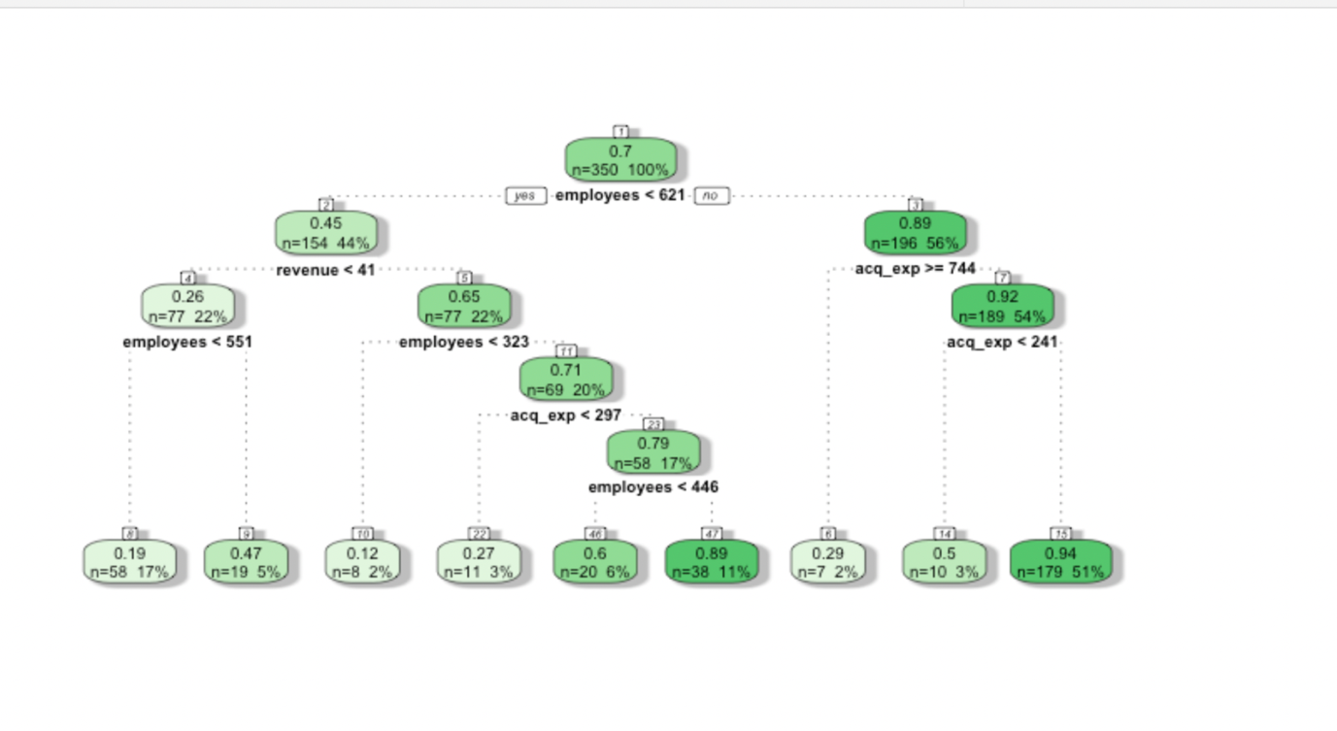

*Fig: Decision Tree*

## Code



*Fig: Optimal tuned hyper-parameters for acquired customers*

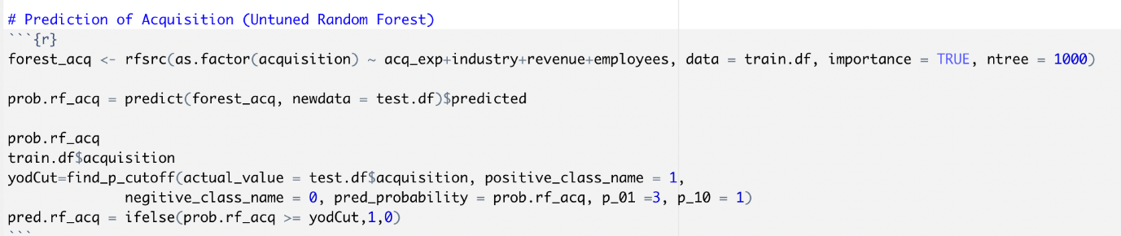

*Fig: Code for prediction of acquisition with untuned random forest*

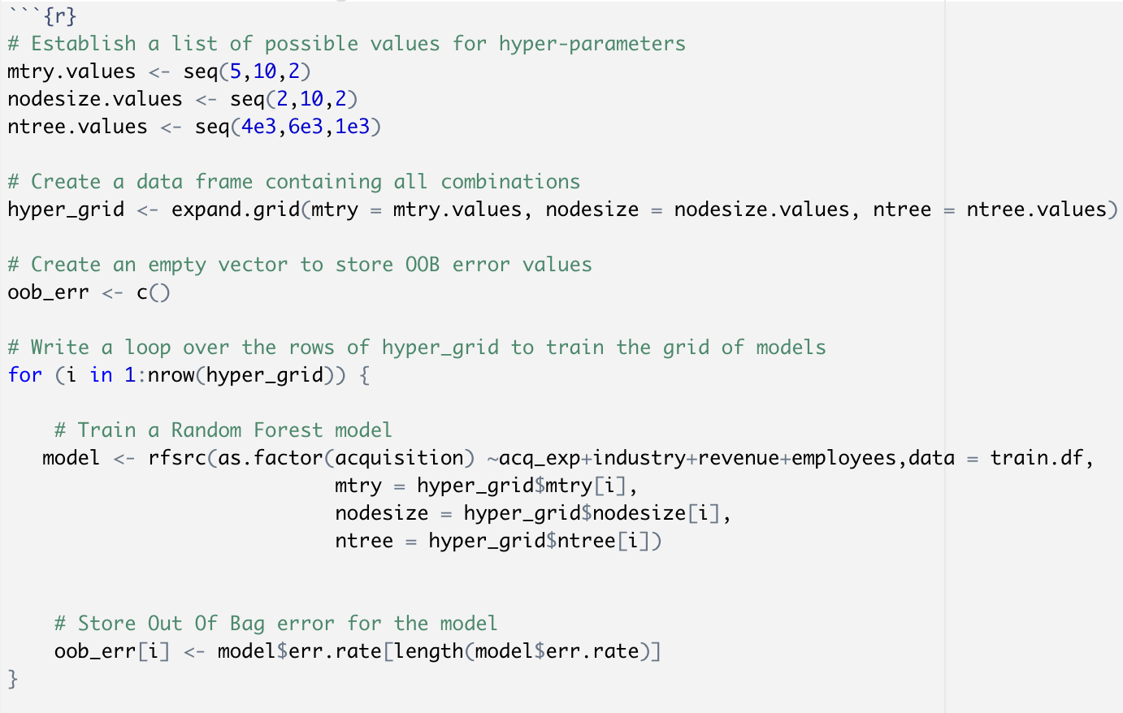

*Fig: code for getting the optimal hyper-parameters*

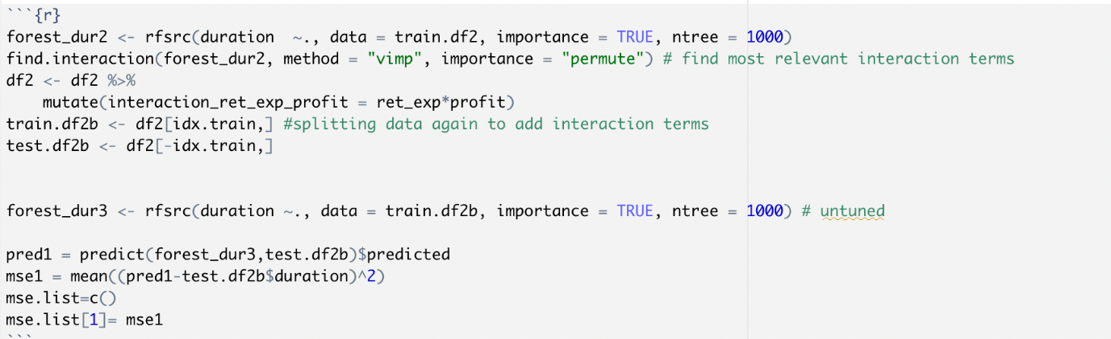

*Fig: code for variable importance*

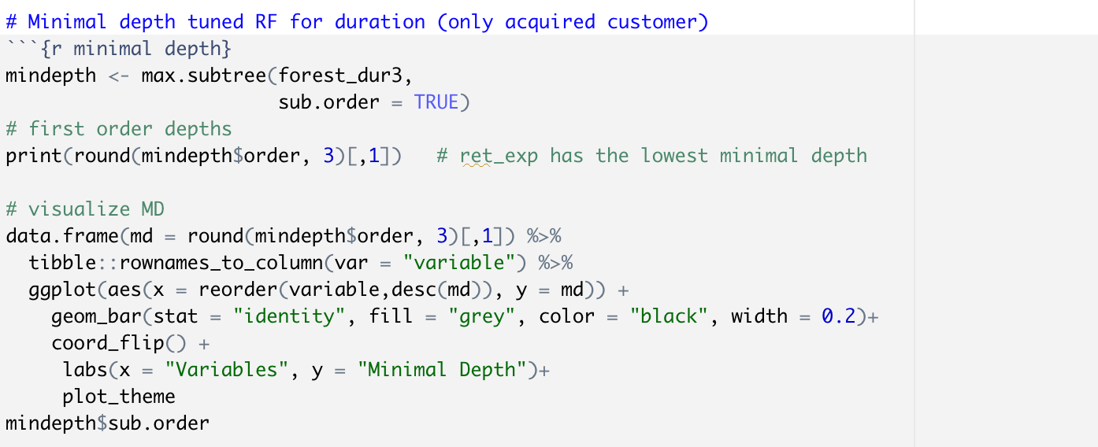

*Fig: code for minimal depth for tuned random forest for acquired customer*

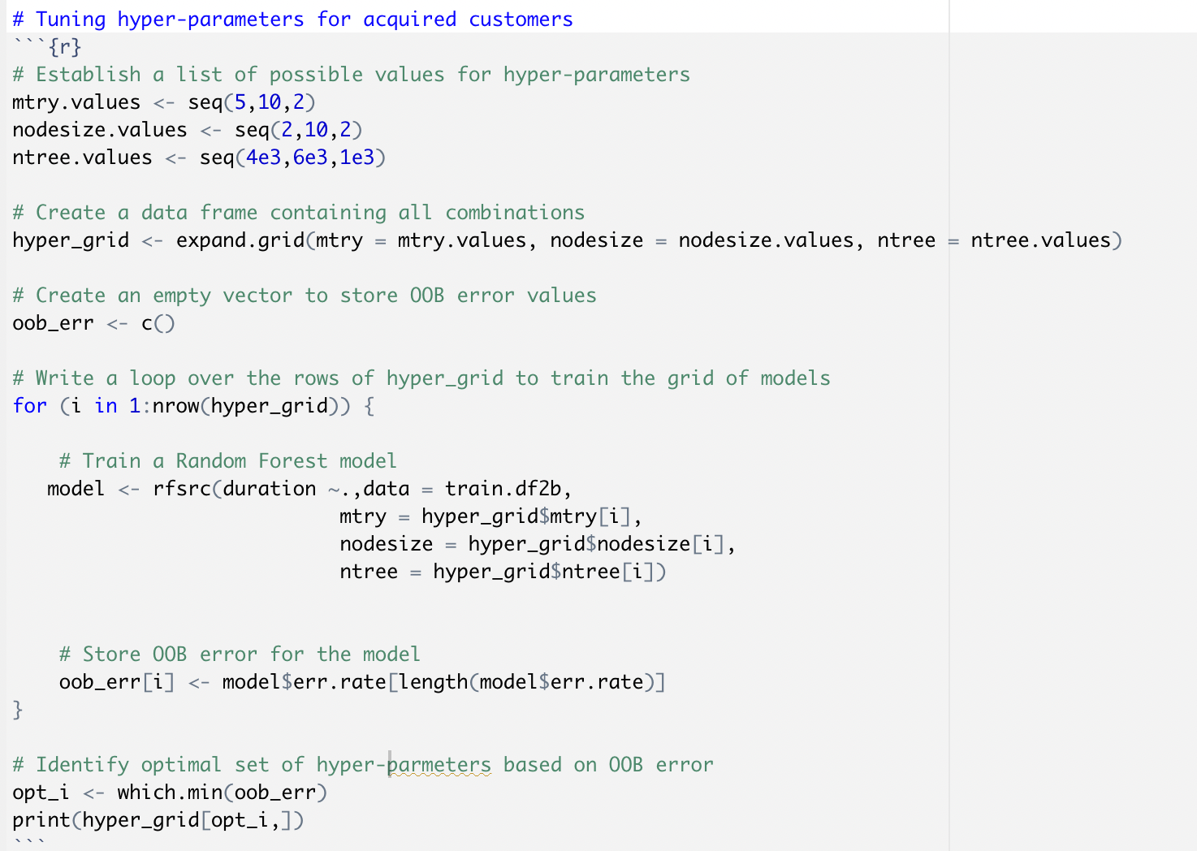

*Fig: code for tuning the hyper-parameters for acquired customers*

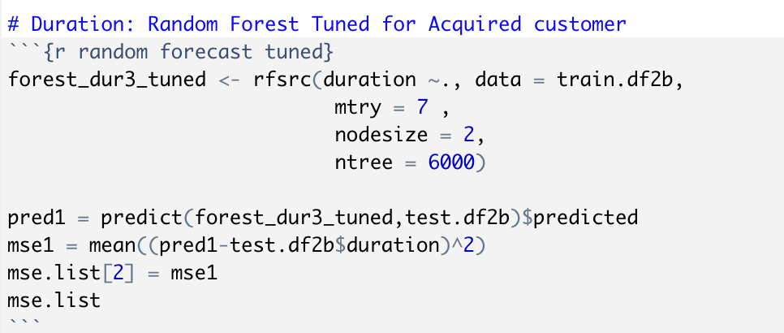

*Fig: code for random forest prediction tuned for acquired customer*

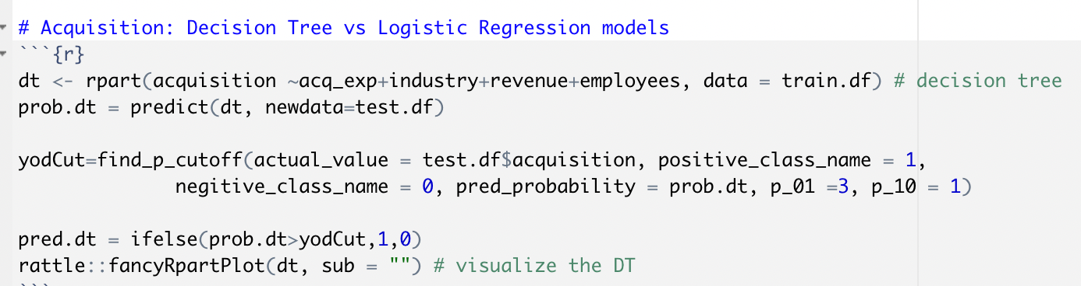

*Fig: code for acquisition variable using decision tree model*

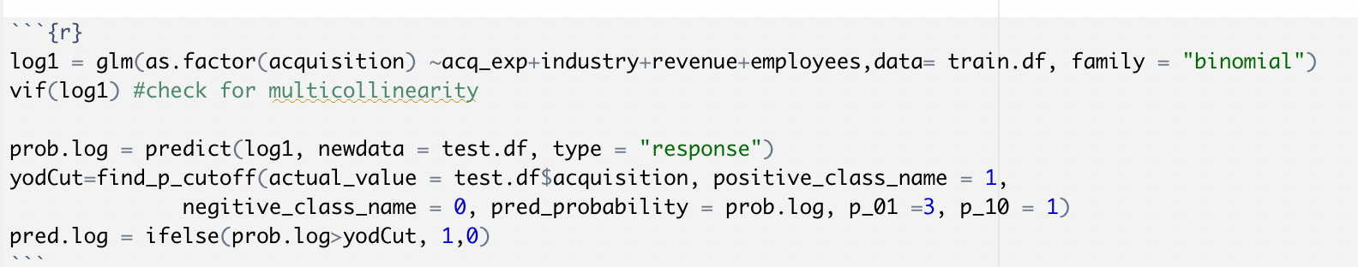

*Fig: code for acquisition variable using logistic regression model*

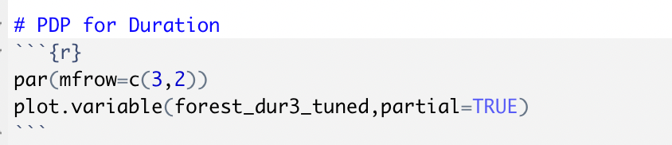

*Fig: PDP plot for duration variable*

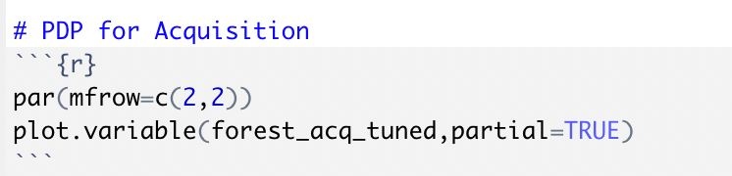

*Fig: PDP plot for acquisition variable*